Assignment – I

**CSE2010 - Advanced C Programming**

**Class Number:** VL2020210504705 **Slot:** L43+L4 **Name :** Prashanth.S **Roll :** 19MID0020

1. Write a C program to print your First name using printf statement. For example if the name is “ABI”, then the output should be (2 marks)

**Program-code**

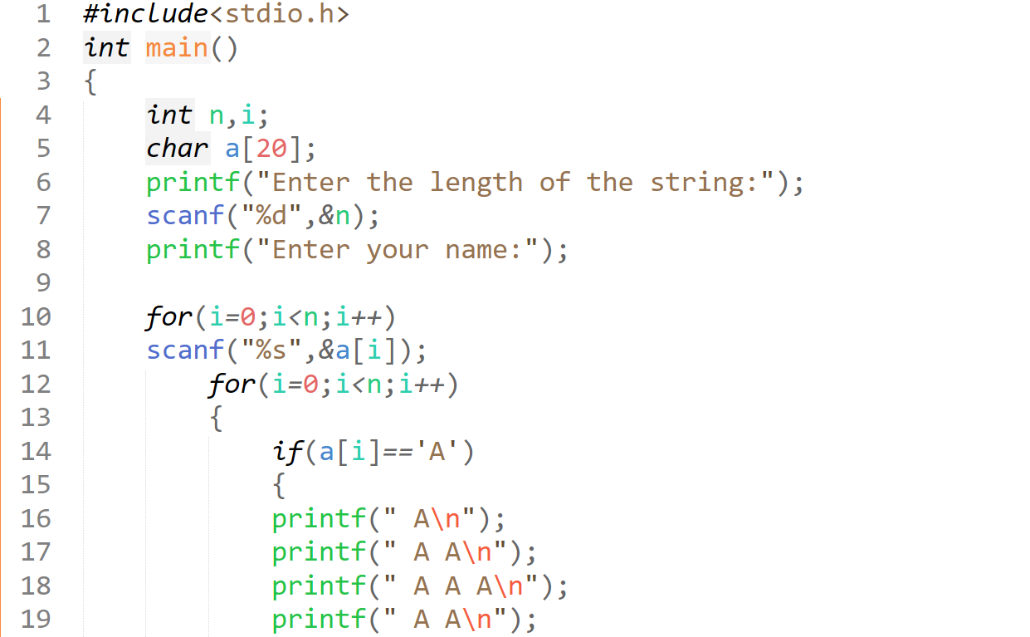

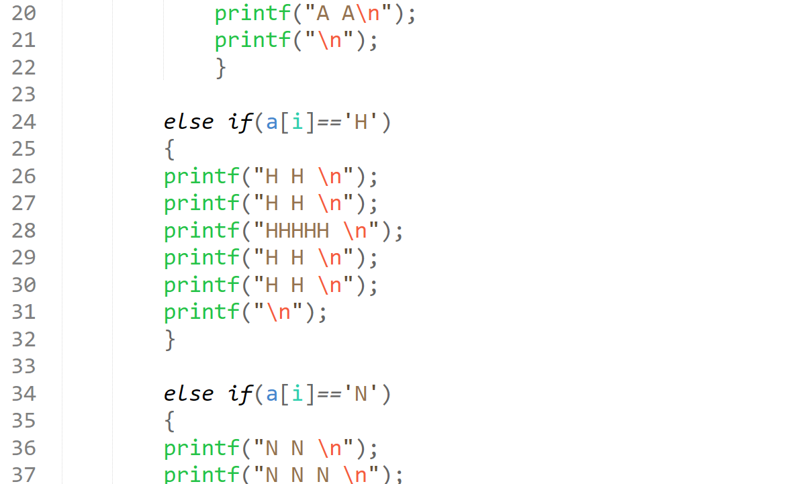

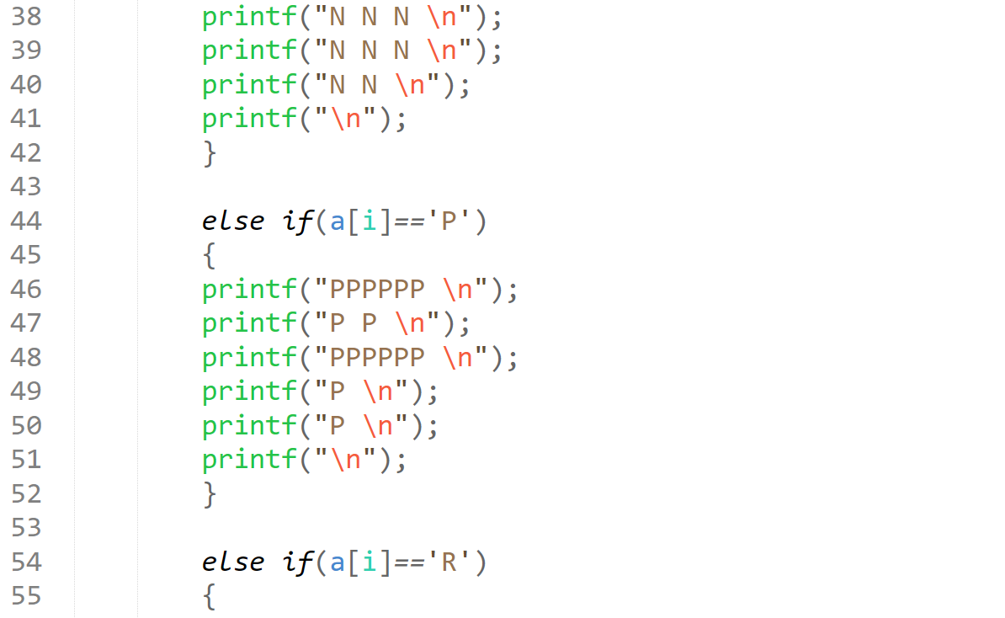

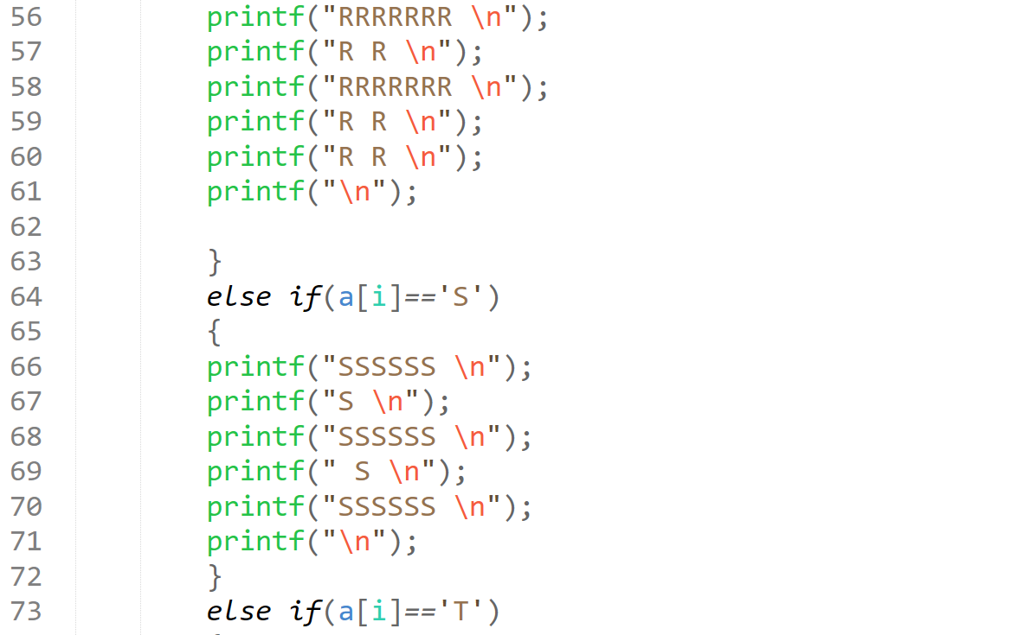

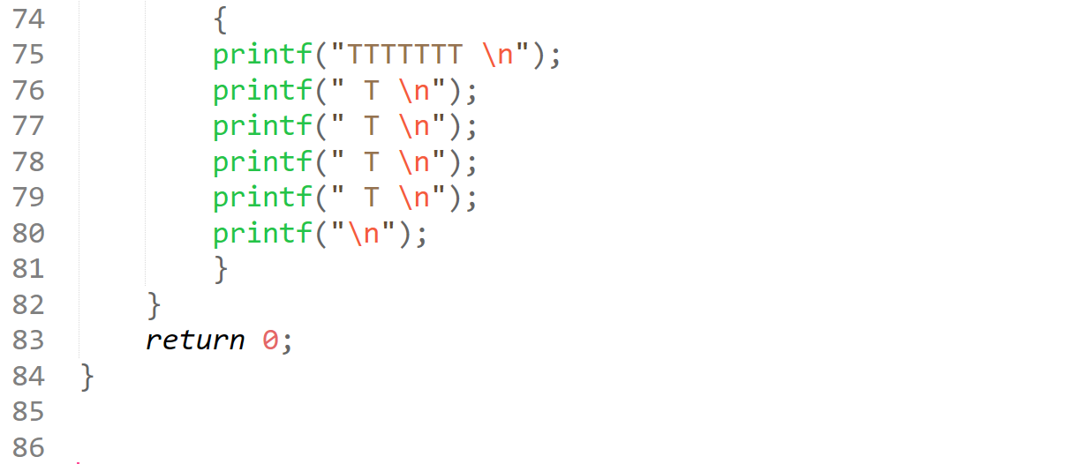

**Output**

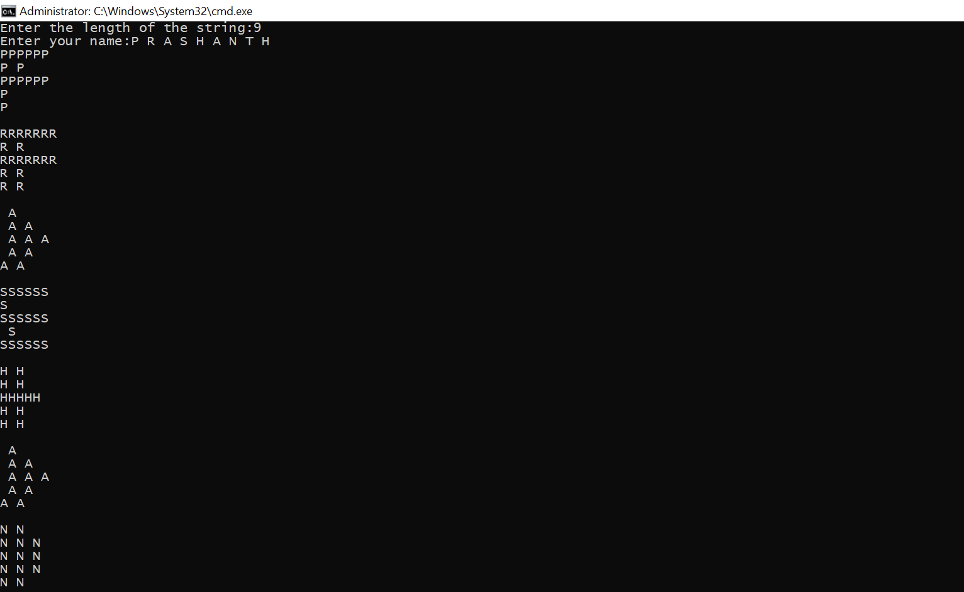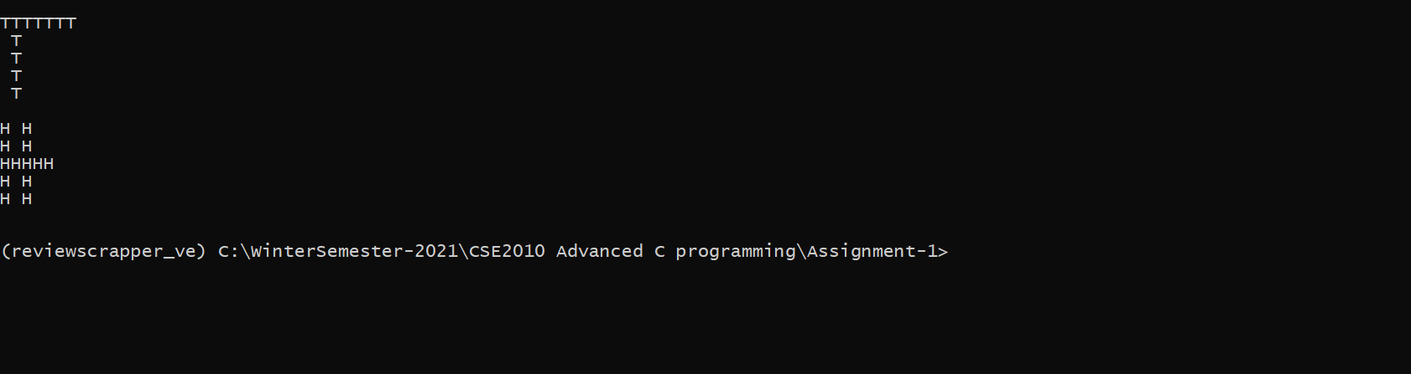

**Program-code**

***#include<stdio.h>***

***int main()***

***{***

***int n,i;***

***char a[20];***

***printf("Enter the length of the string:");***

***scanf("%d",&n);***

***printf("Enter your name:");***

***for(i=0;i<n;i++)***

***scanf("%s",&a[i]);***

***for(i=0;i<n;i++)***

***{***

***if(a[i]=='A')***

***{***

***printf(" A\n");***

***printf(" A A\n");***

***printf(" A A A\n");***

***printf(" A A\n");***

***printf("A A\n");***

***printf("\n");***

***}***

***else if(a[i]=='H')***

***{***

***printf("H H \n");***

***printf("H H \n");***

***printf("HHHHH \n");***

***printf("H H \n");***

***printf("H H \n");***

***printf("\n");***

***}***

***else if(a[i]=='N')***

***{***

***printf("N N \n");***

***printf("N N N \n");***

***printf("N N N \n");***

***printf("N N N \n");***

***printf("N N \n");***

***printf("\n");***

***}***

***else if(a[i]=='P')***

***{***

***printf("PPPPPP \n");***

***printf("P P \n");***

***printf("PPPPPP \n");***

***printf("P \n");***

***printf("P \n");***

***printf("\n");***

***}***

***else if(a[i]=='R')***

***{***

***printf("RRRRRRR \n");***

***printf("R R \n");***

***printf("RRRRRRR \n");***

***printf("R R \n");***

***printf("R R \n");***

***printf("\n");***

***}***

***else if(a[i]=='S')***

***{***

***printf("SSSSSS \n");***

***printf("S \n");***

***printf("SSSSSS \n");***

***printf(" S \n");***

***printf("SSSSSS \n");***

***printf("\n");***

***}***

***else if(a[i]=='T')***

***{***

***printf("TTTTTTT \n");***

***printf(" T \n");***

***printf(" T \n");***

***printf(" T \n");***

***printf(" T \n");***

***printf("\n");***

***}***

***}***

***return 0; }***

**Output**

***Enter the length of the string:9***

***Enter your name:P R A S H A N T H***

***PPPPPP***

***P P***

***PPPPPP***

***P***

***P***

***RRRRRRR***

***R R***

***RRRRRRR***

***R R***

***R R***

***A***

***A A***

***A A A***

***A A***

***A A***

***SSSSSS***

***S***

***SSSSSS***

***S***

***SSSSSS***

***H H***

***H H***

***HHHHH***

***H H***

***H H***

***A***

***A A***

***A A A***

***A A***

***A A***

***N N***

***N N N***

***N N N***

***N N N***

***N N***

***TTTTTTT***

***T***

***T***

***T***

***T***

***H H***

***H H***

***HHHHH***

***H H***

***H H***

2. There are three batsmen from a state. The state government likes to present the best batsman award. Given the name and runs of each person, write a C program to find the best batsman using ternary operator. (1 mark)

**Program-code**

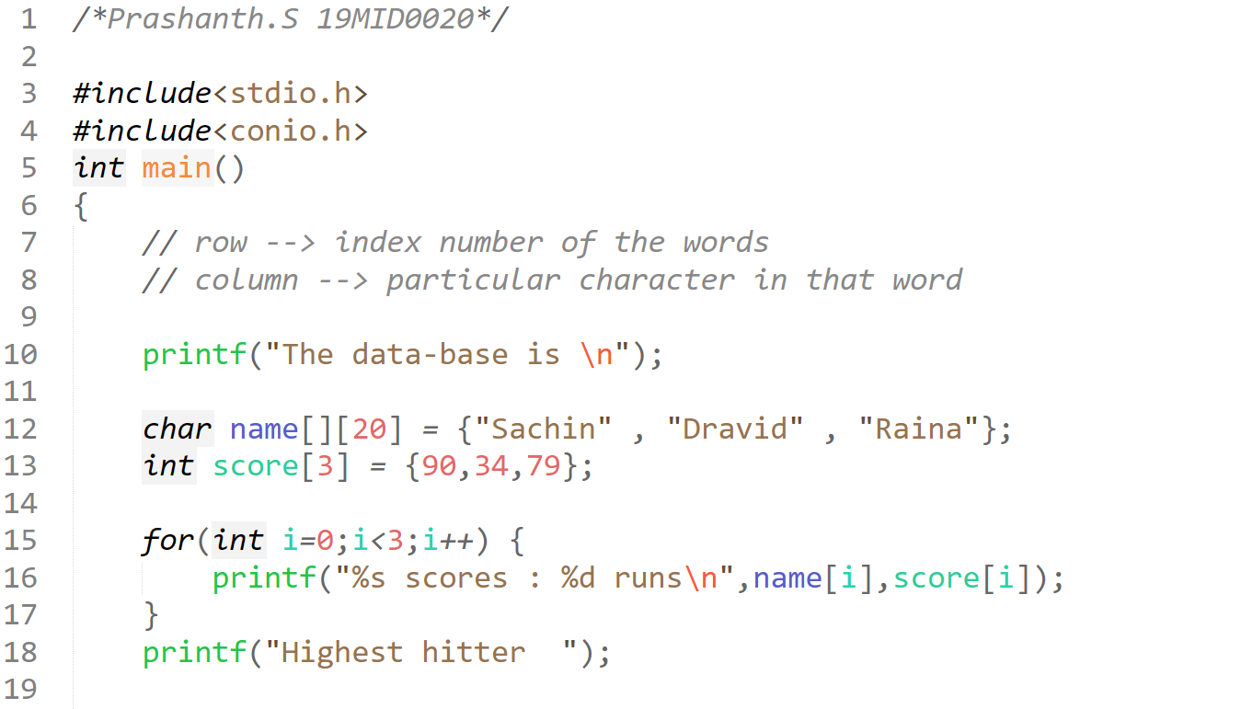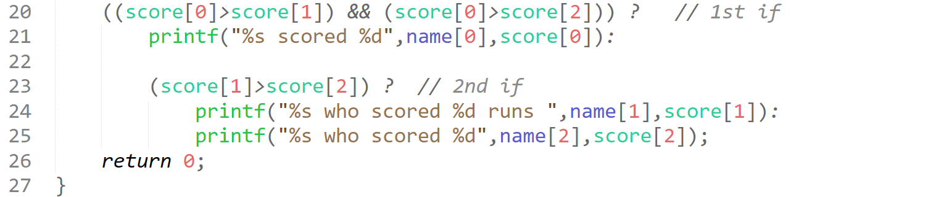

**Output**

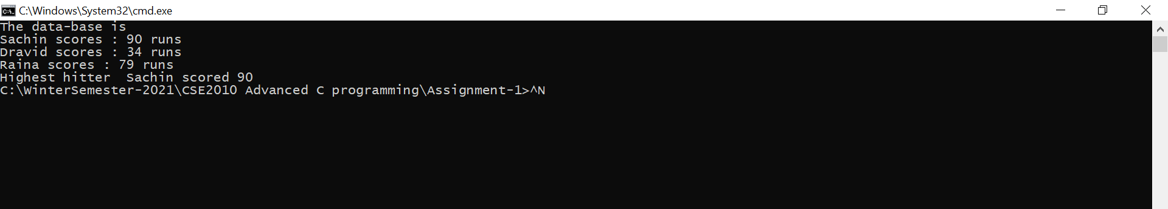

**Program-code**

***#include<stdio.h>***

***#include<conio.h>***

***int main()***

***{***

***// row --> index number of the words***

***// column --> particular character in that word***

***printf("The data-base is \n");***

***char name[][20] = {"Sachin" , "Dravid" , "Raina"};***

***int score[3] = {90,34,79};***

***for(int i=0;i<3;i++) {***

***printf("%s scores : %d runs\n",name[i],score[i]);***

***}***

***printf("Highest hitter ");***

***((score[0]>score[1]) && (score[0]>score[2])) ? // 1st if***

***printf("%s scored %d",name[0],score[0]):***

***(score[1]>score[2]) ? // 2nd if***

***printf("%s who scored %d runs ",name[1],score[1]):***

***printf("%s who scored %d",name[2],score[2]);***

***return 0;***

***}*** **Output**

***The data-base is***

***Sachin scores : 90 runs***

***Dravid scores : 34 runs***

***Raina scores : 79 runs***

***Highest hitter Sachin scored 90***

***C:\WinterSemester-2021\CSE2010 Advanced C programming\Assignment-1>***

3. Let a=0,b=2, c=-2,Find the output of the following expression and also state the reason (1 mark)

--a*(10-b)/2-c++*b+(a+b+c)

**Program-code**

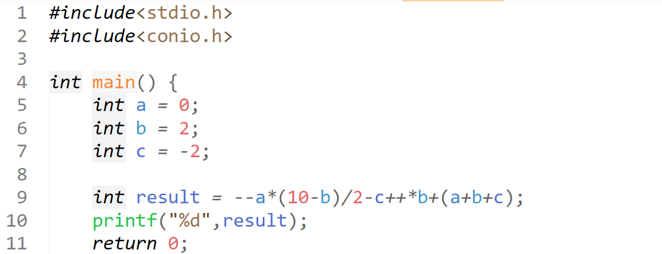

**Output**

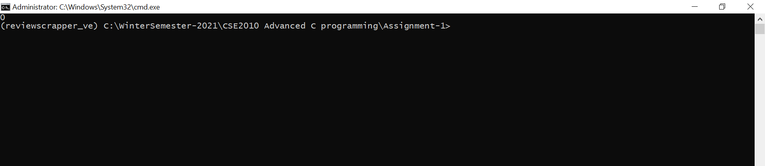

**Program-code**

***#include<stdio.h>***

***#include<conio.h>***

***int main() {***

***int a = 0;***

***int b = 2;***

***int c = -2;***

***int result = --a*(10-b)/2-c++*b+(a+b+c);***

***printf("%d",result);***

***return 0;***

***}***

**Output**

***0***

***(reviewscrapper_ve) C:\WinterSemester-2021\CSE2010 Advanced C programming\Assignment-1>***

1st Precedence 🡪 Pre-Increment and Post-increment Associativity   
2nd Precedence 🡪 Parenthesis  
3rd Precedence 🡪 Multiplication (Associativity 🡪 left to right) and then only division

4. Write a C program to count the number of vowels and consonants in your name irrespective of their case (upper or lower case). The letters b,h,s,p and empty spaces must be considered as special characters not as consonant. (2 marks)

**Program-code**

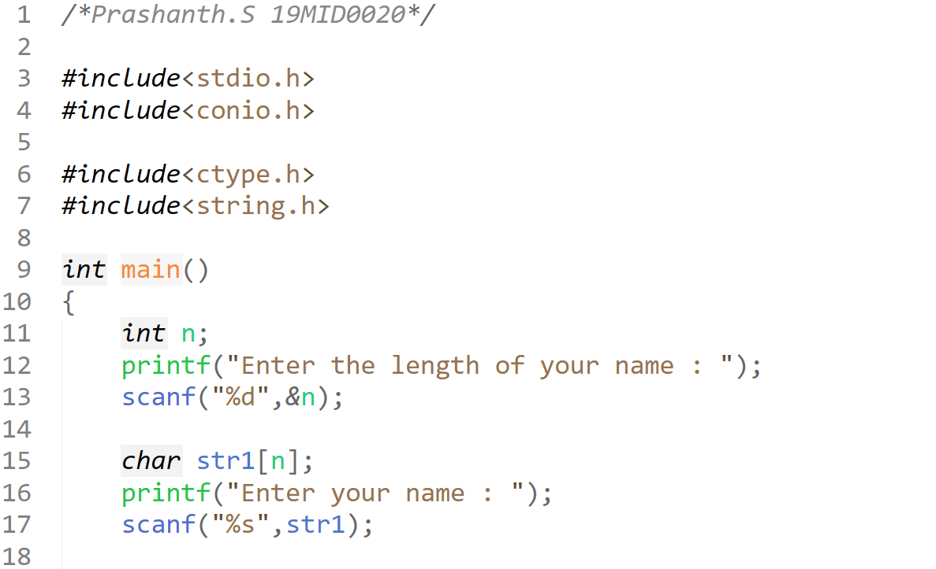

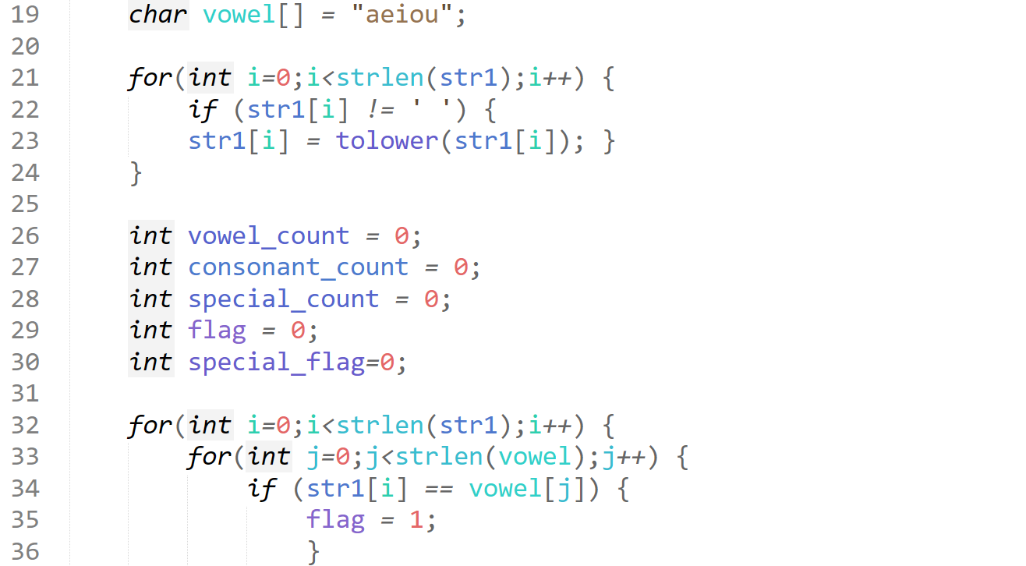

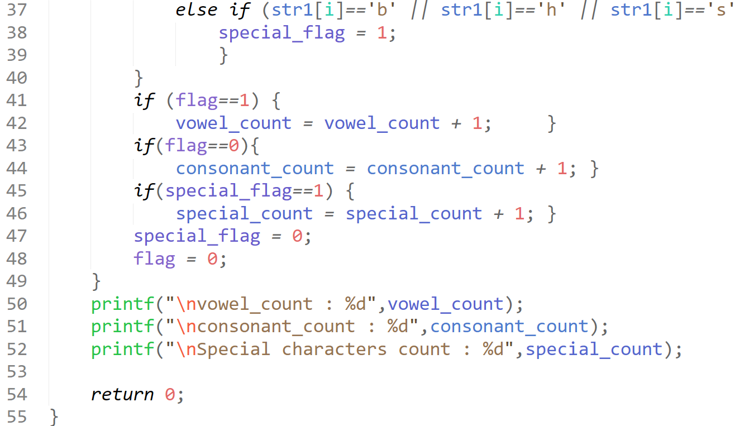

**Output**

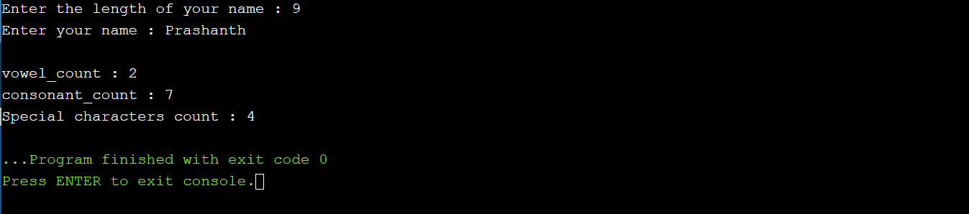

**Program-code**

***/*Prashanth.S 19MID0020*/***

***#include<stdio.h>***

***#include<conio.h>***

***#include<ctype.h>***

***#include<string.h>***

***int main()***

***{***

***int n;***

***printf("Enter the length of your name : ");***

***scanf("%d",&n);***

***char str1[n];***

***printf("Enter your name : ");***

***scanf("%s",str1);***

***char vowel[] = "aeiou";***

***for(int i=0;i<strlen(str1);i++) {***

***if (str1[i] != ' ') {***

***str1[i] = tolower(str1[i]); }***

***}***

***int vowel_count = 0;***

***int consonant_count = 0;***

***int special_count = 0;***

***int flag = 0;***

***int special_flag=0;***

***for(int i=0;i<strlen(str1);i++) {***

***for(int j=0;j<strlen(vowel);j++) {***

***if (str1[i] == vowel[j]) {***

***flag = 1;***

***}***

***else if (str1[i]=='b' || str1[i]=='h' || str1[i]=='s' || str1[i]=='p') {***

***special_flag = 1;***

***}***

***}***

***if (flag==1) {***

***vowel_count = vowel_count + 1; }***

***if(flag==0){***

***consonant_count = consonant_count + 1; }***

***if(special_flag==1) {***

***special_count = special_count + 1; }***

***special_flag = 0;***

***flag = 0;***

***}***

***printf("\nvowel_count : %d",vowel_count);***

***printf("\nconsonant_count : %d",consonant_count);***

***printf("\nSpecial characters count : %d",special_count);***

***return 0;***

***}***

**Output**

***Enter the length of your name : 9***

***Enter your name : Prashanth***

***vowel_count : 2***

***consonant_count : 7***

***Special characters count : 4***

5. Write a C program to perform ATM transaction. The transactions are Balance checking, Cash withdrawal and Cash deposition. Firstly initialize the ATM pin as your registration number. Take the ATM pin and the balance amount as input. If the input pin is equal to the initialized pin, then do the further operations or send an error message “Enter the correct PIN”. Use switch statement to do the operations like Balance checking (1), Cash withdrawal (2), Cash deposition (3) and Quit (4). Use while loop to terminate or restart the process. (3 marks)

**Program-code**

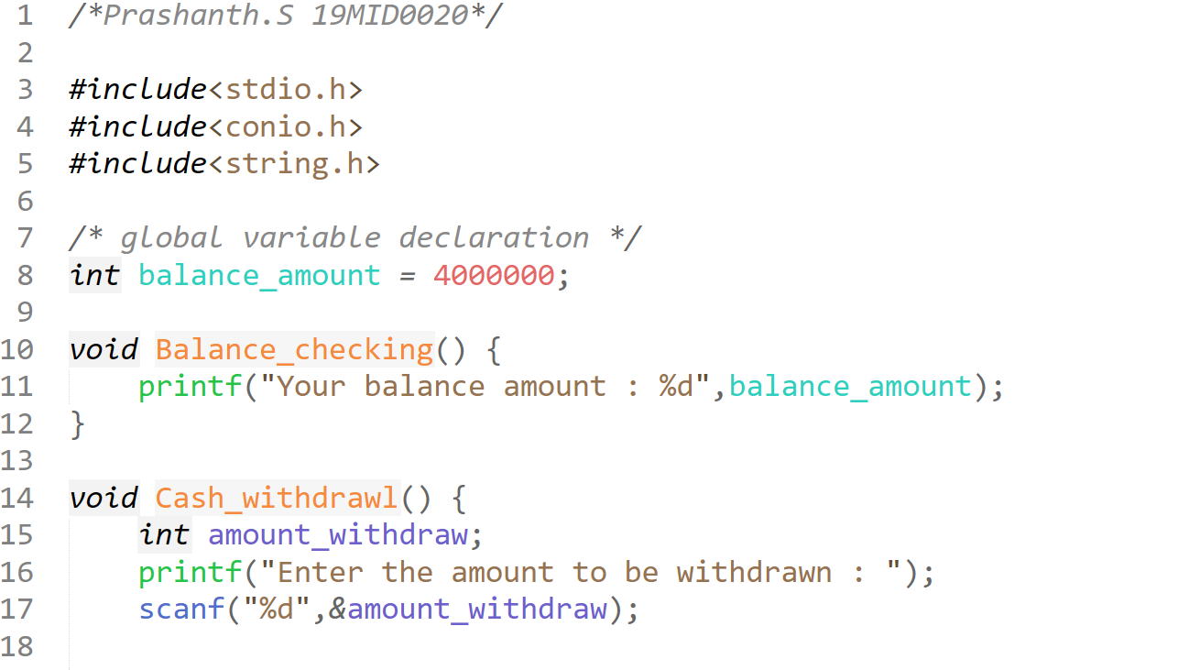  
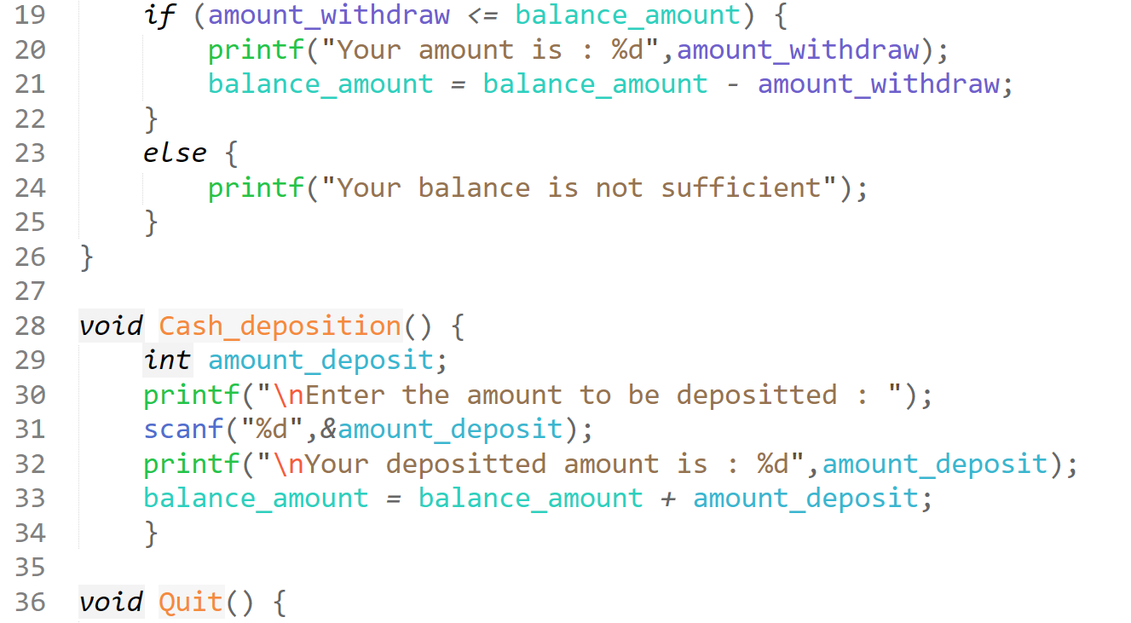

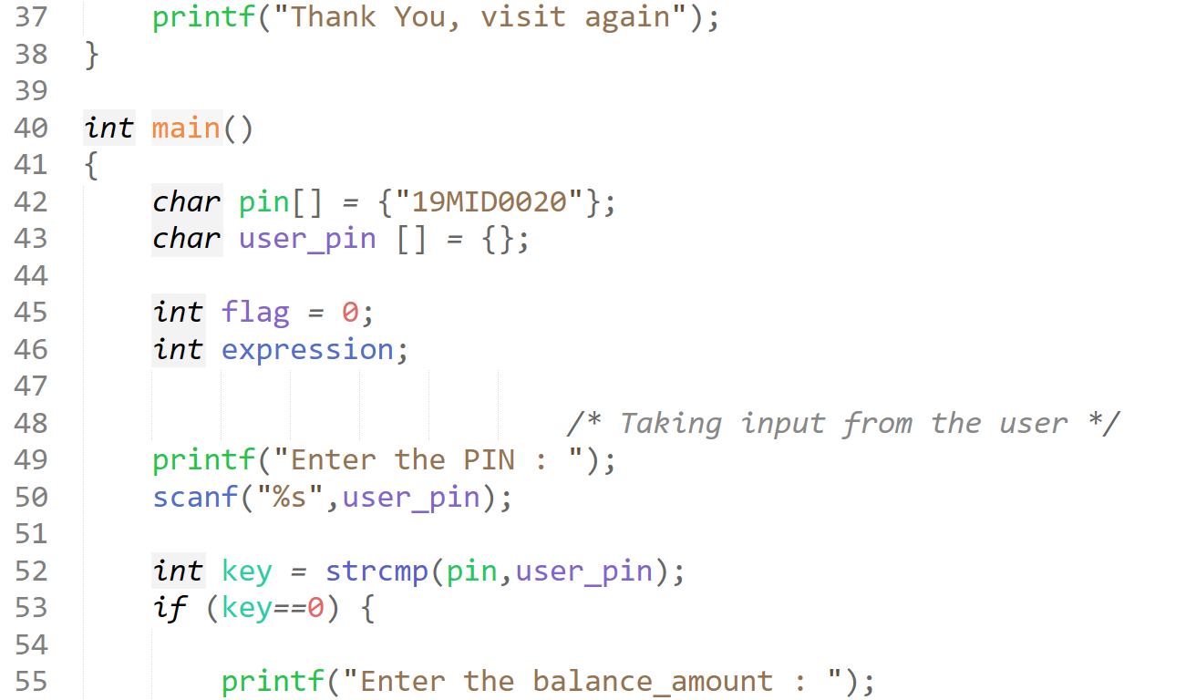

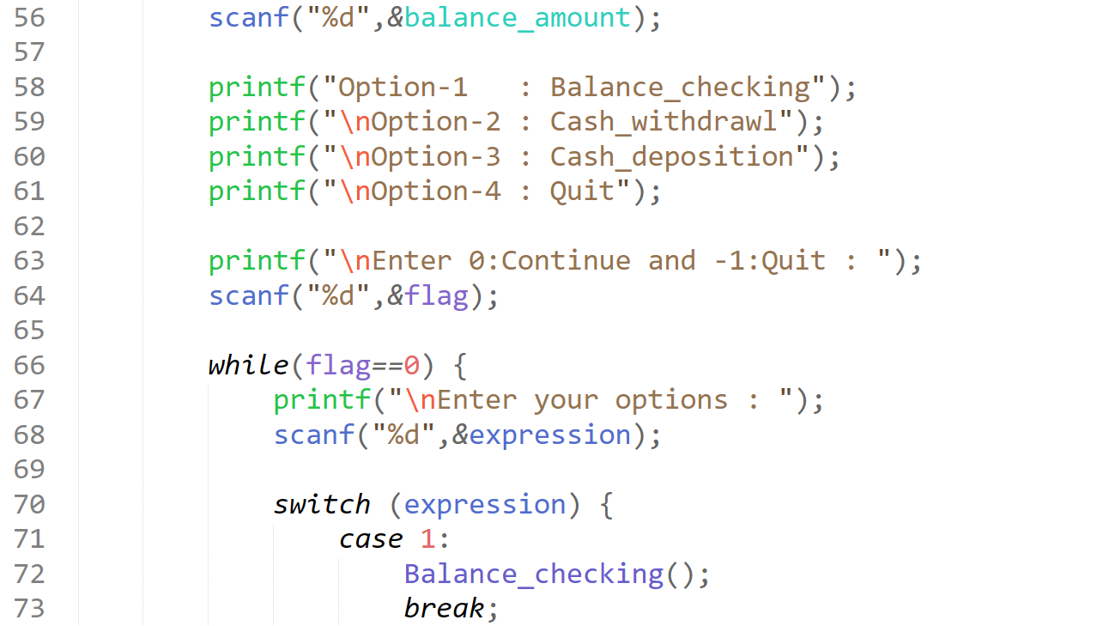

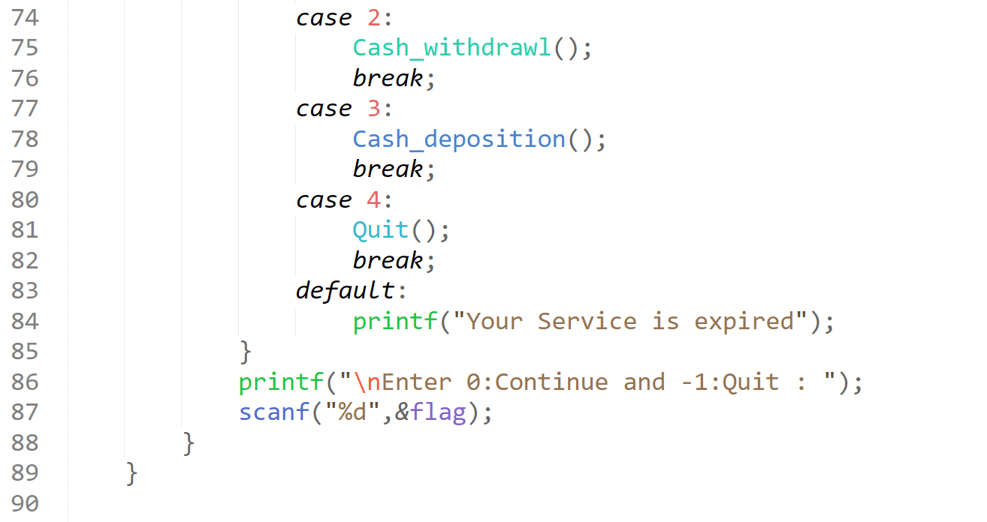  
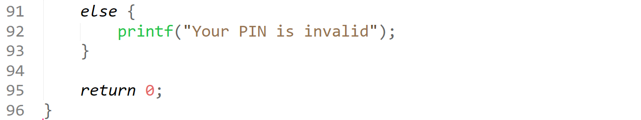

**Output**

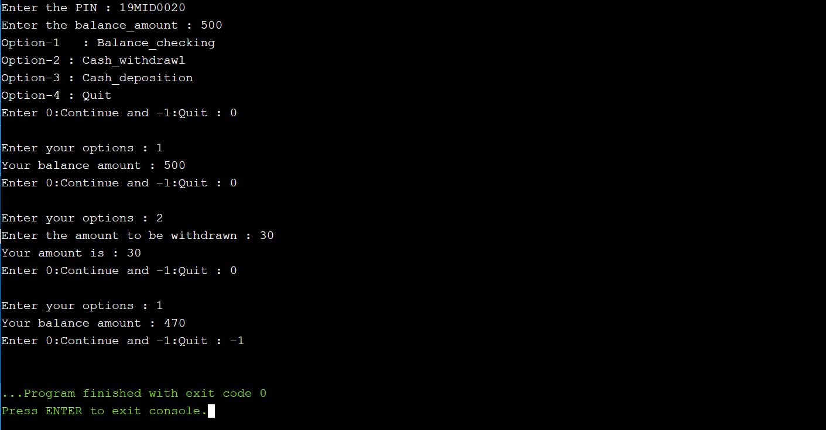

**Program-code**

***/*Prashanth.S 19MID0020*/***

***#include<stdio.h>***

***#include<conio.h>***

***#include<string.h>***

***/* global variable declaration */***

***int balance_amount = 4000000;***

***void Balance_checking() {***

***printf("Your balance amount : %d",balance_amount);***

***}***

***void Cash_withdrawl() {***

***int amount_withdraw;***

***printf("Enter the amount to be withdrawn : ");***

***scanf("%d",&amount_withdraw);***

***if (amount_withdraw <= balance_amount) {***

***printf("Your amount is : %d",amount_withdraw);***

***balance_amount = balance_amount - amount_withdraw;***

***}***

***else {***

***printf("Your balance is not sufficient");***

***}***

***}***

***void Cash_deposition() {***

***int amount_deposit;***

***printf("\nEnter the amount to be depositted : ");***

***scanf("%d",&amount_deposit);***

***printf("\nYour depositted amount is : %d",amount_deposit);***

***balance_amount = balance_amount + amount_deposit;***

***}***

***void Quit() {***

***printf("Thank You, visit again");***

***}***

***int main()***

***{***

***char pin[] = {"19MID0020"};***

***char user_pin [] = {};***

***int flag = 0;***

***int expression;***

***/* Taking input from the user */***

***printf("Enter the PIN : ");***

***scanf("%s",user_pin);***

***int key = strcmp(pin,user_pin);***

***if (key==0) {***

***printf("Enter the balance_amount : ");***

***scanf("%d",&balance_amount);***

***printf("Option-1 : Balance_checking");***

***printf("\nOption-2 : Cash_withdrawl");***

***printf("\nOption-3 : Cash_deposition");***

***printf("\nOption-4 : Quit");***

***printf("\nEnter 0:Continue and -1:Quit : ");***

***scanf("%d",&flag);***

***while(flag==0) {***

***printf("\nEnter your options : ");***

***scanf("%d",&expression);***

***switch (expression) {***

***case 1:***

***Balance_checking();***

***break;***

***case 2:***

***Cash_withdrawl();***

***break;***

***case 3:***

***Cash_deposition();***

***break;***

***case 4:***

***Quit();***

***break;***

***default:***

***printf("Your Service is expired");***

***}***

***printf("\nEnter 0:Continue and -1:Quit : ");***

***scanf("%d",&flag);***

***}***

***}***

***else {***

***printf("Your PIN is invalid");***

***} return 0; }***

**Output**

***Enter the PIN : 19MID0020***

***Enter the balance_amount : 500***

***Option-1 : Balance_checking***

***Option-2 : Cash_withdrawl***

***Option-3 : Cash_deposition***

***Option-4 : Quit***

***Enter 0:Continue and -1:Quit : 0***

***Enter your options : 1***

***Your balance amount : 500***

***Enter 0:Continue and -1:Quit : 0***

***Enter your options : 2***

***Enter the amount to be withdrawn : 30***

***Your amount is : 30***

***Enter 0:Continue and -1:Quit : 0***

***Enter your options : 1***

***Your balance amount : 470***

***Enter 0:Continue and -1:Quit : -1***

6. Tell me about a time when you came up with a new approach to the above problems. (1 mark to show up your individuality, answer should be sound and sensible – Answers repeated no marks, so don’t share your answers)

**In the vowel and consonant program, I took each and every character in my name and cross verified with vowels(in a separate array) and special characters(individual elements), and then classified into vowel_count and special_character count.  
Rest of the words belong to consonants.**

**In ATM bank problem, I asked the input from the user while he was depositing the withdrawing money apart from PIN and balance_amount.**